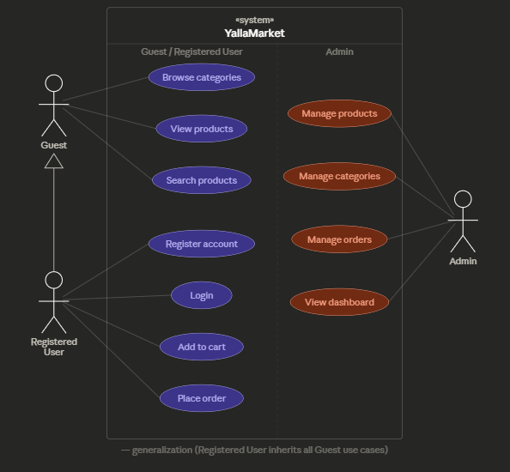
Actors:
- Guest — unauthenticated visitor (left)
- Registered User — authenticated customer (left, below Guest)
- Admin — store manager (right)
Relationships:
- The hollow triangle arrow between Registered User and Guest is a generalization — meaning Registered User inherits all Guest's use cases (browse, view, search) without repeating the lines
- Purple ellipses = Guest/User use cases
- Coral ellipses = Admin-only use cases
- The dashed vertical line separates the two zones visuall

